Task No 01: Create a visiting card using MS publisher.

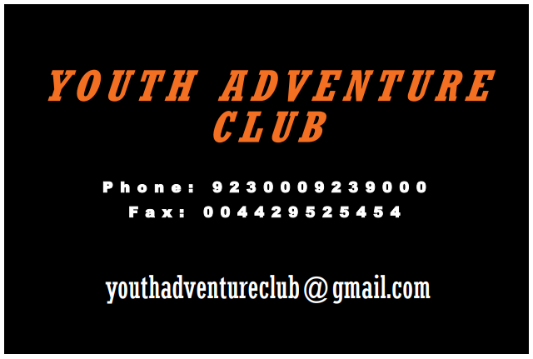

Task No 02: Create a Brochure using MS publisher.

